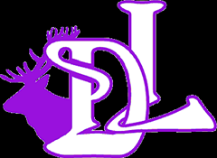Should I send my child into school today? – a Ditton Lodge Guide for Parents
- Keep your child off school and at home.
- Call NHS 111 or visit www.gov.uk/coronavirus and arrange for a test.
- Your child and your family must self-isolate until you have the results of the test.
Negative Test
- Your child and family may stop isolating.
- Your child can return to school once they have been fever free for 48 hours.
Positive Test
- NHS Test and Trace will advise you on the next steps to take.
- You must inform the school as soon as possible.

Children who are otherwise well but have:
- Sore throat (without a temperature)
- Runny nose
- Mild colds
can go to school as normal.
Does your child have:
- A new, continuous cough? (coughing for over an hour)
- A temperature? (over 38 degrees centigrade)
- A loss or change in taste or smell?
NO
YES
Keep your child off school.
NO
YES
Would you have kept your child off school before Covid-19?

