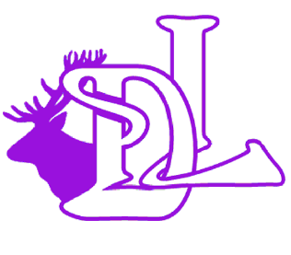Rights Respecting Article 28: You have the right to a good quality education and to learn.

Behaviour Blueprint
3 Expectations
- Ready
- Respectful
- Safe
Adult Behaviour
- Calm, consistent and fair
- Body language – poker face
- Give first attention to best conduct
- Relentlessly bothered
- Meet and greet
- Recognise over and above
- Role models to children
Over and above recognition
- Praise
- Postcards
- Phone call home
- Learning line / display
- Star on display board
- Celebration certificate
- Cheers
- Learning on celebration board

• We are READY to learn –
• We arrive at school on time.
• We have the correct uniform and PE kit.
• We have our equipment ready.
• We show that we are listening and our minds are ready to try our very best. (SHINE)
We follow the 8 secrets of success to support learning behaviours.

• We are RESPECTFUL –
• We listen when others speak and we respect the property of our friends and the school.
• We respect that other people have different ideas, beliefs and backgrounds to our own.
• We respect that people may look different and have different needs but we all feel the same emotions.
• We respect the law and the rules of school and society.
Restorative Questions
- What has happened?
- What were you thinking at the time?
- Who has been affected by the actions?
- How have they been affected?
- What needs to be done to make things right?
- How can we do things differently in the future?

• We are SAFE –
• We move around school in a safe manner.
• We follow instructions to keep ourselves safe.
• We use equipment safely.
• We stay safe online and make safe choices in our community.
Scripts
- I’ve noticed that….I can see that…
- The expectation is….
- Thank you for listening
- Improve/shine….
- …. Is making the right choice and has….
- You have 2 choices….

Stepped Consequences
- Stop and wait. Use proximity to model
- Reminder of the expectation
- Second reminder using the script
(You may give 2 choices here depending whether the child needs adaptations)
- Time out (record on CPOMS)
- Restorative conversation
Other Strategies
- ‘Shine’ to get attention
- Use of lollipop sticks
- Using music / counting / timers during transitions
- Display photographs/create videos of how you would like it to look
- Use of music & timers during independent learning
- Zones of Regulation
Relentless Routines
Fantastic Walking / Terrific Travelling/ Legendary Lining Up – learning space, learning time/Tight Transitions
Manners: Please and Thank You’s Meet and Greet

